**CHAPTER 4**

**IMPLEMENTATION**

System implementation is the important stage of project when the theoretical design is tuned into practical system.

**4.1 Creating Database Using MySQL**

Queries used for creating database and different tables used in Shop Inventory and Billing System are given below.

**To create new database**

mysql> create database register;

**To use newly created database**

mysql> use register;

Database changed

**To create table reg**

mysql> CREATE TABLE `register`.`reg` (

`fname` VARCHAR(45) NULL,

`lname` VARCHAR(45) NULL,

`uname` VARCHAR(45) NOT NULL,

`pass` VARCHAR(45) NULL,

`repass` VARCHAR(45) NULL,

`cnum` VARCHAR(45) NOT NULL,

PRIMARY KEY (`cnum`, `uname`)) ;

Query OK, 0 rows affected (1.44 sec)

**To create table inventory**

mysql>CREATE TABLE `register`.`inventory` (

`id` VARCHAR(10) NOT NULL,

`name` VARCHAR(45) NULL,

`price` VARCHAR(45) NULL,

`category` VARCHAR(45) NULL,

`quantity` VARCHAR(45) NULL,

PRIMARY KEY (`id`));

**To insert values to reg table**

mysql> insert into reg values('ashwil', 'd', 'ash', '4545', '4545', '7895487525');

Query OK, 1 row affected (0.18 sec)

mysql> insert into reg values('mourice', 'dsouza', 'mou', '4720', '4720', '4578457845');

Query OK, 1 row affected (0.18 sec)

mysql> insert into reg values('nithin', 'dsouza', 'ntn', '123', '123', '5487458745');

Query OK, 1 row affected (0.18 sec)

**To view values in table inventory**

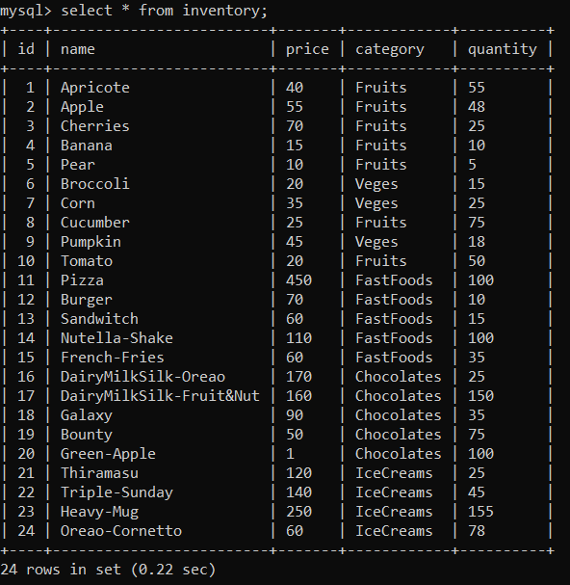

**To view values in table reg**

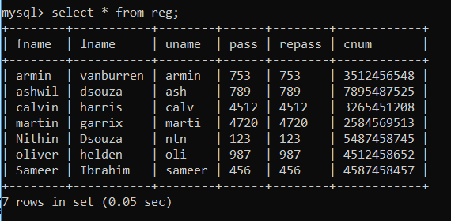

**4.2 Stored Procedure**

A stored procedure is a prepared SQL code that can be reused over and over again. So if an SQL query needs to be written over and over again, save it as a stored procedure, and then just call it to execute it. It is also possible to pass parameters to a stored procedure, so that the stored procedure can act based on the parameter value(s) that is passed.

**Stored procedure used in Shop Inventory and Billing System is as follows**

DELIMITER $$

USE `register`$$

CREATE DEFINER=`root`@`localhost` PROCEDURE `LOGIN_PROC`(IN NAME VARCHAR(20), IN PASS VARCHAR (10))

BEGIN

SELECT uname,pass FROM reg WHERE uname= NAME AND pass = PASS;

END$$

DELIMITER ;